**BITS PILANI, DUBAI CAMPUS**

**DUBAI INTERNATIONAL ACADEMIC CITY, DUBAI**

**SECOND SEMESTER 2023 – 2024**

**COURSE:** CSF303 (Computer Network)

**COMPONENT:** Tutorial Sheet 9 **DATE:** 29th April 2024

1. You have been allocated a class A network address of **29.0.0.0**. You need to create at least 20 networks and each network will support a maximum of 160 hosts. Would the following two subnet masks Work?

**255.255.0.0** and or **255.255.255.0**

1. You have been allocated a class B network address of 135.1.0.0 and and need to create 4 subnets each with around 200 hosts what is the easiest mask to use to satisfy the criteria?
2. You have been allocated a class C network address of 211.1.1.0 and are using the default subnet mask of 255.255.255.0 how may hosts can you have?
3. Subnet the Class C IP Address 195.1.1.0 So that you have 10 subnets each with a maximum 12 hosts on each subnet. List the Address on host 1 on subnet 0,1,2,3,10.
4. Fill the following table

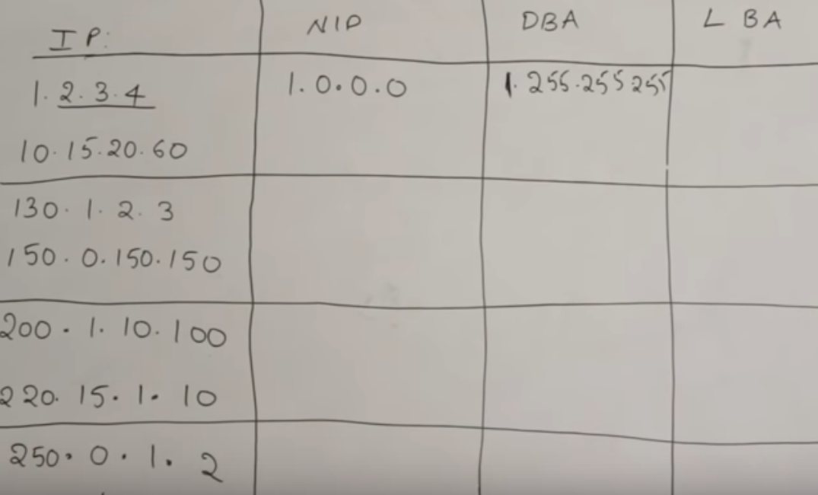

1. Subnet the following IP Address 30.40.50.10/25 So that you have 16 subnets each with a maximum 6 hosts on each subnet.